EXPERIMENT– 4:
VERIFICATION OF SYSTEM PROPERTIES: LINEARITY, TIME INVARIANCE, CAUSALITY AND STABILITY

OBJECTIVE
i) To verify the linearity and time-invariance properties of continuous-time and discrete-time
systems using suitable input signals and system responses.
(ii) To analyze and classify continuous-time and discrete-time systems as causal or non-causal
based on their input-output relationships.
(iii) To analyze and classify systems as memoryless or dynamic based on their dependence on
present and past input values.
(iv) To verify the BIBO stability of given systems and classify them as stable or unstable for
real-time automation applications.

i) To verify the linearity and time-invariance properties of continuous-time and discrete- time systems using suitable input signals and system responses.

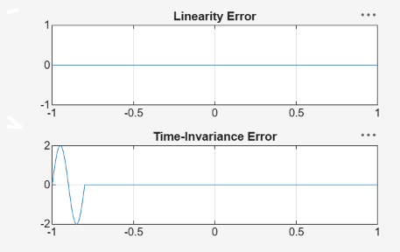
(ii) To analyze and classify continuous-time and discrete-time systems as causal or non-
causal ba sed on their input-output relationships.

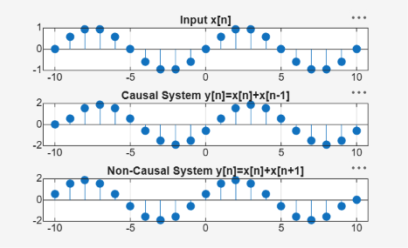

(iii) To analyze and classify systems as memoryless or dynamic based on their dependence on present and past input values.

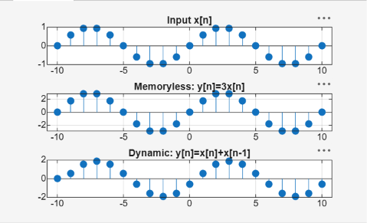

(iv) To verify the BIBO stability of given systems and classify them as stable or unstable
for real-time automation applications.

